I did some research for the Smart Farming System for Sustainable Agriculture and looked at example backend implementations. I will first focus on weather conditions, Spraying, soil structure, and efficient water usage.

1) To begin with weather conditions, I found a piece of code at github and that helps retrieve weather data and raise awareness about it:

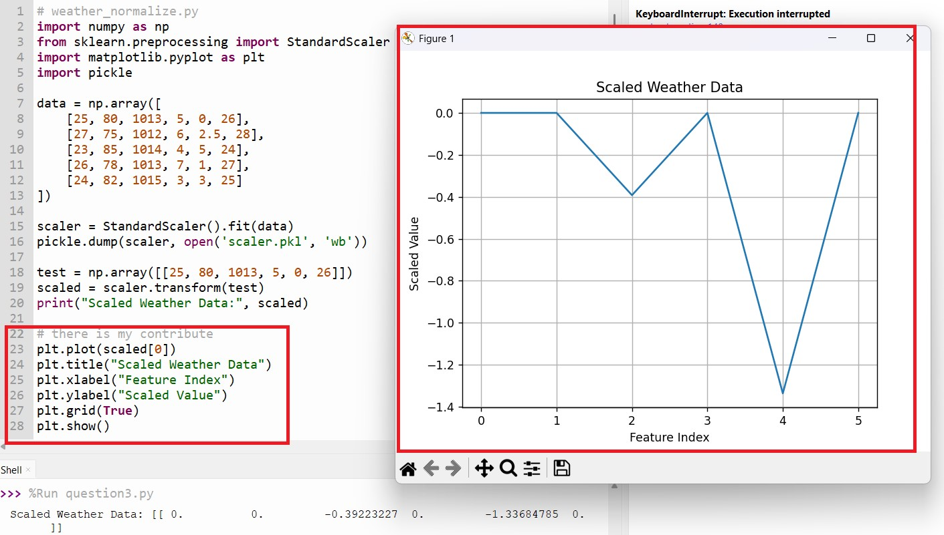

This code standardizes weather data for machine learning and saves the scaler for future use .but ı have another idea for the develop this code. my contribution, I added a graph that visualizes the normalized weather features. This helps both users and developers understand how the original values are transformed and compare different features more clearly: ı checked [Pyplot tutorial — Matplotlib 3.10.3 documentation](https://matplotlib.org/stable/tutorials/pyplot.html) and ı checked openAL. I learned how to graph the data and ı try to add this code:

I downloaded some libraries and tried it myself.

After testing, the graph worked and showed the results clearly.

I also added screenshots of the installed libraries and the graph result.

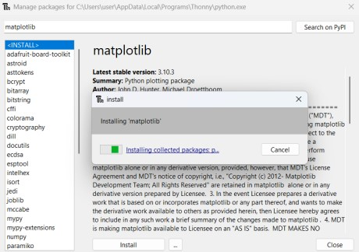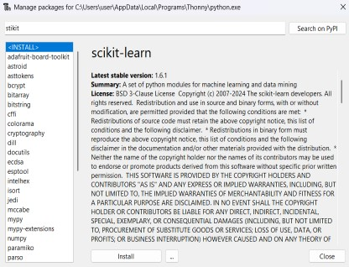

2) The second issue is Spraying.I think that we should the consider is the spraying apply or not.if we want to decide this,we take the some data for the data analist and we apply our code.our code should involve the temperature, humidity ,wind speed, rain probability.for my search[:What farmers need to know about pesticide weather considerations | Agrio,](https://agrio.app/What-Every-Farmer-Needs-to-Know-About-Pesticide-Weather-Considerations/)I searced this website and they do a applying for spraying.they focun on 4 topics (temperature , wind speed , rain probablitiy , humidity) firstly,temperature is the play key role for plant.if the temperature is so high.the plant is damaged. secondly, wind speed is effect the spraying . If the wind is too strong, it can carry the pesticide away. thirdly, rain probablitiy.if it rains, your pesticide can be below the your plants. finally, humidity, If the humidity is too low, the pesticide may lose its effect before reaching the plant.I did a simply program to these functions.

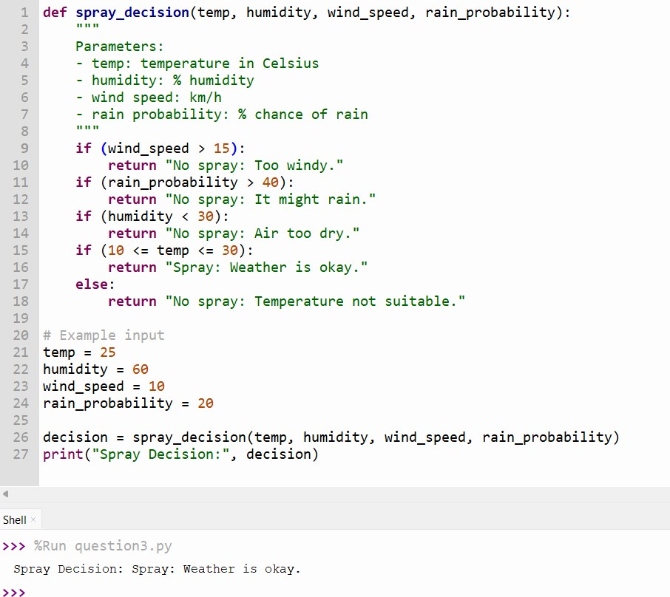

In this part, I wrote a simple function that decides whether spraying is suitable or not. I used basic weather values like temperature, humidity, wind speed, and chance of rain.

The system checks if the weather conditions are safe, and gives a short message like "Spray" or "No spray".

For example, if the wind is too strong or it might rain soon, the system warns not to spray.

I tested the function with example data that could come from a sensor or a weather API in a real project.

When I ran the code, the result was "Spray: Weather is okay", which means the conditions are good for spraying.

This function is useful to help farmers make a quick and safe decision before spraying.

3)the third topic is soin structure. Based on my research, important factors in soil analysis are pH level, moisture, nutrients (N, P, K), organic matter, and soil texture.

These elements are very important for healthy plant growth and good crop yield.

For example:

* If the **pH level is too low or too high**, plants cannot absorb nutrients properly.
* If the **soil is too dry** or cannot hold water well, plants may not get enough water.

**Source:** FAO Soils Portal [– https://www.fao.org/soils-portal/en/](https://www.fao.org/soils-portal/en/)

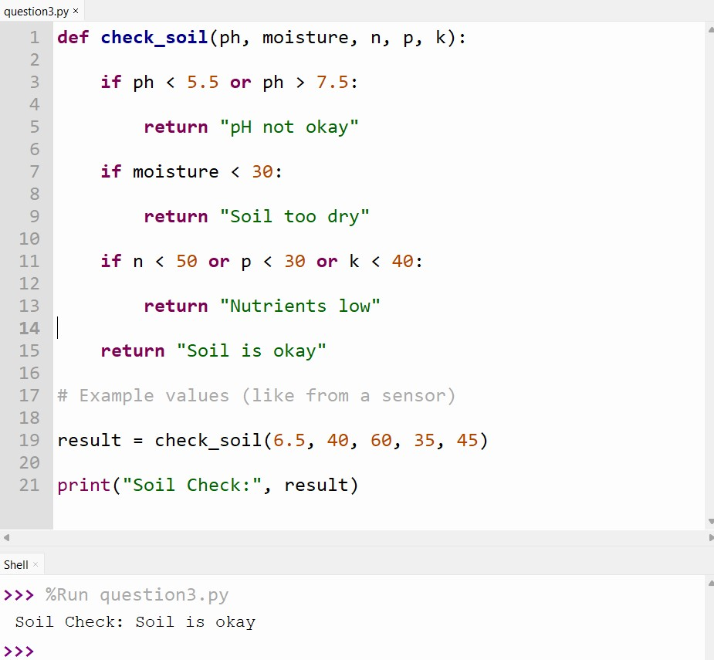

I wrote a simple function that analyzes soil conditions using pH, moisture, and nutrient levels (N-P-K).

The system checks if the pH is in the normal range (5.5 to 7.5), and if the soil is too dry or missing nutrients.

If any of these values are too low or high, it gives a short recommendation such as "Irrigation needed" or "Check acidity".

I tested the function with example values, and it returned: **“Soil conditions are suitable.”**

4)last and the most important thing is efficient water usage .for the people lifes water is essential for this topic.

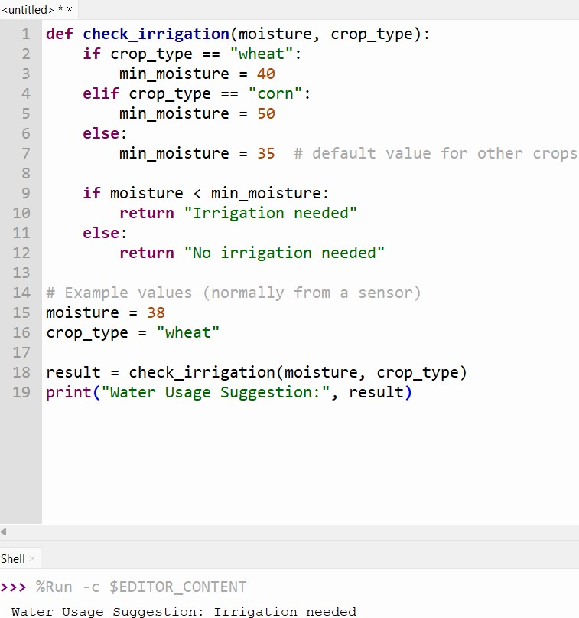

This function, check_irrigation, helps decide whether irrigation is needed based on the soil's moisture level and the crop type.

It works by:

* Setting a **minimum moisture threshold** based on the crop:

o Wheat: 40% o Corn: 50% o Other crops: 35%

* If the current **moisture level is below** the required threshold, the system returns:

**"Irrigation needed"**

* Otherwise, it returns:

**"No irrigation needed"**

In this example, the crop is **wheat** and the moisture level is **38**, so the function suggests **irrigation**.

This helps ensure efficient water usage and prevents overwatering or water waste in smart farming systems.

Burhan Çelik Project Report:

In this project, I learned a few important things. First, if we want to work on a project, we must divide it into sections and assign tasks to everyone. Everyone should work together for the project to move forward. For example, if one of our team members doesn’t handle the backend part, it will affect other areas like design or frontend. Therefore, everyone needs to pay attention to their tasks.

I was responsible for the backend part of the software. To write the code, I did research on the topic, reviewed example projects, and added them to my own code. Although this code is at a beginner level, it forms the foundation of the project.

To summarize my report, I want to say that I learned that software development is a team effort. If one person neglects their task, it impacts everyone. If we want to do something in a specific area, we need to learn the basics of that topic first. Most importantly, I learned that the way a project starts sets the tone for the entire process. If I had moved forward without planning properly, I might have made mistakes, but we should first focus on planning and then start the work.